DO:

* VM
  + Recreate one OS (Ubuntu or CentOS) and create two-three different disks

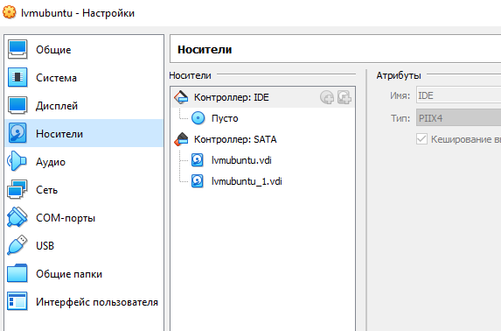

* + Group two of them (non-root disk) in the logical group with LVM (keep 30% of the space not allocated).

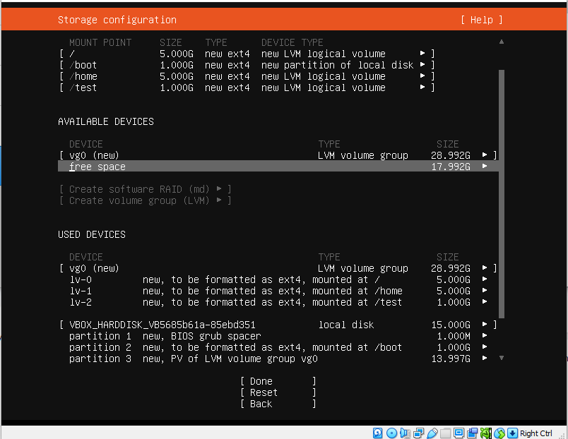

* + Mount some directory to this logical disk (e.g. /test)
  + Move /home directory to this logical disk as well (as a dedicated mount point)

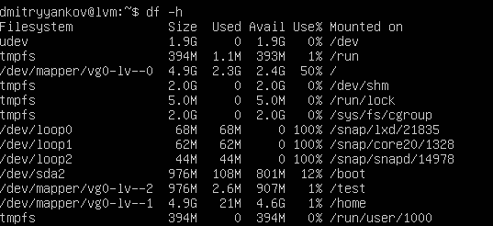

* + Add more space to this LVM (from the unallocated space available) .

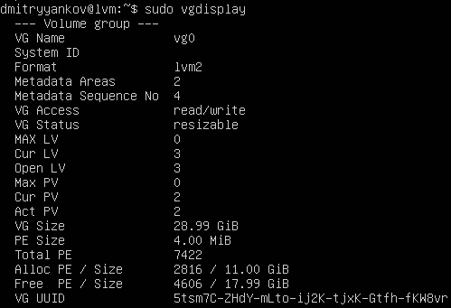

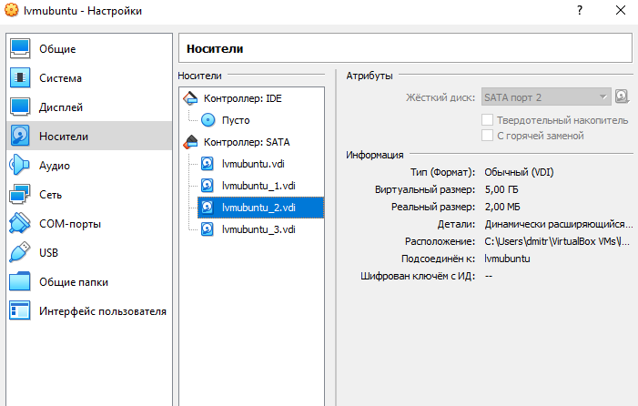



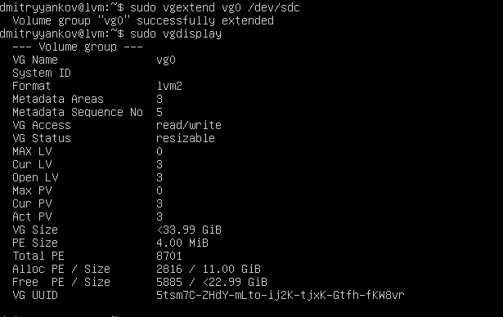

* + Create an user called “footer”, add it to the group “barer”
  + Create a directory /test/foobar and set permission to it only for user “footer” and group “barer”

